| Supplementary Table 1. Characteristics of essential workers from a large-scale company in the Greater Mexico City Metropolitan Area, March 2020-November 2021 | | | | | | | | | | | | |
| --- | --- | --- | --- | --- | --- | --- | --- | --- | --- | --- | --- | --- |
|  | Cycle 1: September 22-29, 2020 | | | Cycle 2: November 9-13, 2020 | | | Cycle 3: January 4-9, 2021 | | | Cycle 4: November 22-26, 2021 | | |
|  | Crude | Estimated % (weighted) | 95% CI | Crude | Estimated % (weighted) | 95% CI | Crude | Estimated % (weighted) | 95% CI | Crude | Estimated % (weighted) | 95% CI |
| **Total** | 965 | 100 | 100 | 1,195 | 100 | 100 | 760 | 100 | 100 | 1,011 | 100 | 100 |
| **Men** | 831 | 85.77 | 83.55-87.83 | 965 | 80.05 | 77.62-82.11 | 642 | 83.78 | 80.97-86.43 | 838 | 83.04 | 80.70-85.21 |
| **Women** | 134 | 14.23 | 12.17-16.45 | 230 | 19.95 | 17.89-22.38 | 118 | 16.22 | 13.57-19.03 | 173 | 16.96 | 14.79-19.30 |
| **Under 35** | 322 | 37.65 | 34.21-40.91 | 379 | 37.04 | 33.92-40.10 | 213 | 33.46 | 29.83-37.34 | 314 | 31.07 | 28.18-33.88 |
| **35 - 44** | 312 | 37.38 | 33.94-40.72 | 355 | 37.06 | 33.88-40.07 | 248 | 38.58 | 35.14-42.77 | 352 | 35.09 | 32.21-38.21 |
| **45 - 59** | 220 | 24.68 | 21.88-27.73 | 252 | 25.48 | 22.63-28.47 | 194 | 27.67 | 24.02-31.08 | 340 | 33.21 | 30.43-36.30 |
| **60 over** | 1 | 0.25 | 0.04-0.66 | 2 | 0.34 | 0.04-0.77 | 0 | 0.13 | 0.00-0.57 | 5 | 0.58 | 0.18-1.10 |
| **PCR positive** | 9 | 1.29 | 0.60-2.11 | 16 | 1.66 | 0.95-2.46 | 34 | 4.89 | 3.35-6.58 | 0 | 0.24 | 0.03-0.57 |
| **IgG positive** | 316 | 27.17 | 23.61-30.46 | 329 | 20.75 | 17.93-23.72 | 207 | 20.42 | 16.68-24.16 | 1,003 | 99.59 | 99.08-99.92 |
| **RD-STDC in previous 6 months** | 118 | 13.16 | 11.03-15.46 | 125 | 10.69 | 8.82-12.47 | 73 | 10.17 | 8.09-12.35 | 67 | 6.79 | 5.14-8.34 |

| **Supplementary Table 2.** Characteristics of a convenience sample of essential workers from a large-scale company in the Greater Mexico City Metropolitan Area, March 2020-November 2021 | | | | | | | | | | | | |
| --- | --- | --- | --- | --- | --- | --- | --- | --- | --- | --- | --- | --- |
|  | Cycle 1: September 22-29, 2020 | | | Cycle 2: November 9-13, 2020 | | | Cycle 3: January 4-9, 2021 | | | Cycle 4: November 22-26, 2021 | | |
| Variable | Crude | Estimate (weighted) | 95% CI | Crude | Estimate (weighted) | 95% CI | Crude | Estimate (weighted) | 95% CI | Crude | Estimate (weighted) | 95% CI |
| Total | 575 | 100 | 100 | 456 | 100 | 100 | 893 | 100 | 100 | 637 | 100 | 100 |
| Men | 483 | 84.32 | 81.39-87.05 | 406 | 87.86 | 84.82-90.57 | 720 | 80.02 | 77.26-82.64 | 513 | 78.03 | 74.63-81.45 |
| Women | 92 | 15.68 | 12.95-18.61 | 50 | 12.14 | 9.43-15.18 | 173 | 19.98 | 17.36-22.74 | 124 | 21.97 | 18.55-25.37 |
| Under 35 | 162 | 31.16 | 26.52-35.09 | 101 | 18.89 | 8.05-37.25 | 231 | 32.96 | 29.49-36.30 | 176 | 28.94 | 25.26-32.61 |
| 35 - 44 | 182 | 38.49 | 34.16-43.17 | 151 | 28.13 | 15.72-46.98 | 266 | 37.11 | 33.63-40.84 | 217 | 34.60 | 30.85-38.35 |
| 45 - 59 | 150 | 29.82 | 26.03-34.19 | 111 | 38.11 | 26.53-57.84 | 215 | 29.76 | 26.60-33.36 | 213 | 35.86 | 31.78-40.04 |
| 60 over | 0 | 0.39 | 0.03-1.07 | 0 | 6.18 | 0.00-23.94 | 0 | 0.10 | 0.00-0.43 | 0 | 0.34 | 0.00-1.73 |
| PCR positive | 6 | 1.56 | 0.63-2.74 | 13 | 3.12 | 1.64-5.10 | 71 | 8.41 | 6.48-10.31 | 0 | 1.18 | 0.14-2.63 |
| IgG positive | 169 | 22.97 | 18.81-27.49 | 125 | 21.53 | 16.40-26.63 | 225 | 17.98 | 14.67-21.22 | 635 | 98.71 | 97.20-99.81 |
| RD-STDC in previous 6 months | 66 | 12.55 | 9.85-15.42 | 37 | 8.70 | 5.86-11.56 | 85 | 9.61 | 7.81-11.67 | 60 | 9.92 | 7.45-12.44 |

| Supplementary Table 3. Seroprevalence in a convenience sample of essential workers of a large-scale company in the Greater Mexico City Metropolitan Area, March 2020-November 2021 | | | | | | | | | | | | |
| --- | --- | --- | --- | --- | --- | --- | --- | --- | --- | --- | --- | --- |
|  | Cycle 1: September 22-29, 2020 | | | Cycle 2: November 9-13, 2020 | | | Cycle 3: January 4-9, 2021 | | | Cycle 4: November 22-26, 2021 | | |
| Variable | Sample size | Estimate (weighted) | 95% CI | Sample size | Estimate (weighted) | 95% CI | Sample size | Estimate (weighted) | 95% CI | Sample size | Estimate (weighted) | 95% CI |
| Men | 483 | 24.59 | 19.67-29.28 | 406 | 22.28 | 17.17-27.69 | 720 | 19.41 | 15.60-22.72 | 513 | 98.50 | 96.97-99.84 |
| Women | 92 | 19.32 | 8.47-31.73 | 50 | 17.37 | 4.08-31.55 | 173 | 13.87 | 7.50-21.45 | 124 | 97.12 | 94.39-99.43 |
| Under 35 | 162 | 12.49 | 5.79-20.52 | 101 | 25.58 | 5.26-46.75 | 231 | 18.38 | 11.94-25.35 | 176 | 97.41 | 95.06-99.48 |
| 35 - 44 | 182 | 34.59 | 26.36-41.87 | 151 | 31.96 | 8.12-51.15 | 266 | 20.61 | 14.71-26.51 | 217 | 97.43 | 95.14-99.39 |
| 45 - 59 | 150 | 17.48 | 10.69-26.50 | 111 | 39.23 | 19.38-59.58 | 215 | 15.75 | 9.42-21.92 | 213 | 97.98 | 95.83-99.63 |
| 60 over | 0 | 47.61 | 8.09-89.12 | 0 | 48.69 | 11.10-87.69 | 0 | 49.49 | 12.72-86.40 | 0 | 49.77 | 10.87-87.16 |
| Self-reported respiratory illness | 148 | 47.94 | 39.14-57.60 | 102 | 40.04 | 29.45-51.83 | 279 | 25.61 | 19.04-31.81 | 169 | 97.23 | 94.62-99.56 |
| No self-reported respiratory illness | 334 | 10.77 | 6.37-15.48 | 247 | 13.65 | 7.96-20.33 | 399 | 12.49 | 7.90-17.07 | 239 | 97.97 | 95.92-99.75 |
| No RD-STDC in previous 6 months | 509 | 17.60 | 13.36-21.92 | 419 | 19.47 | 14.50-24.82 | 808 | 14.63 | 11.51-17.91 | 577 | 98.64 | 97.11-99.82 |
| RD-STDC in previous 6 months | 66 | 61.30 | 48.80-73.85 | 37 | 46.53 | 30.91-63.87 | 85 | 50.51 | 38.96-62.27 | 60 | 94.62 | 86.89-99.38 |
| *95% Credible Intervals.  **This information was obtained with a questionnaire, some study participants had this missing.  RD-STDC: Respiratory disease-Short term disability claim.  Cycles 1,2, and 3: seropositivity is for anti-N antibodies and for cycle 4, anti-S antibodies. | | | | | | | | | | | | |

| Supplementary table 4. Vaccination status and seroprevalence for each vaccine brand in a convenience sample of essential workers of a large-scale company in the Greater Mexico City Metropolitan Area, November 2021 | | | | | | |
| --- | --- | --- | --- | --- | --- | --- |
|  | Vaccinated workers | | | Antibodies within vaccine group | | |
| Vaccine | Sample size (crude) | Weighted estimate (%) | 95% CI | Sample size (crude) | Weighted estimate (%) | 95% CI |
| Astrazeneca | 269 | 47.58 | 43.52-51.81 | 269 | 97.70 | 95.80-99.66 |
| Cansino* | 1 | 0.75 | 0.13-1.56 | 1 | 62.99 | 23.07-91.73 |
| Janssen | 2 | 1.03 | 0.28-2.03 | 2 | 57.25 | 21.59-94.05 |
| Moderna | 12 | 2.80 | 1.53-4.12 | 12 | 85.18 | 66.01-98.14 |
| Pfizer | 27 | 5.43 | 3.56-7.39 | 27 | 91.26 | 79.03-98.82 |
| Sinovac | 46 | 8.99 | 6.66-11.36 | 46 | 94.89 | 88.00-99.13 |
| Sputnik v | 80 | 14.88 | 11.79-17.95 | 80 | 96.02 | 91.04-99.34 |
| Unspecified | 94 | 16.45 | 13.68-19.43 | 94 | 95.63 | 89.69-99.53 |
| No | 7 | 1.73 | 0.75-2.90 | 6 | 69.08 | 40.10-91.47 |
| *Estimation assuming each percent is distributed Beta with a standard uniform prior. For small sample sizes the prior is strong enough that the posterior estimate does not move far enough from 0.5. | | | | | | |

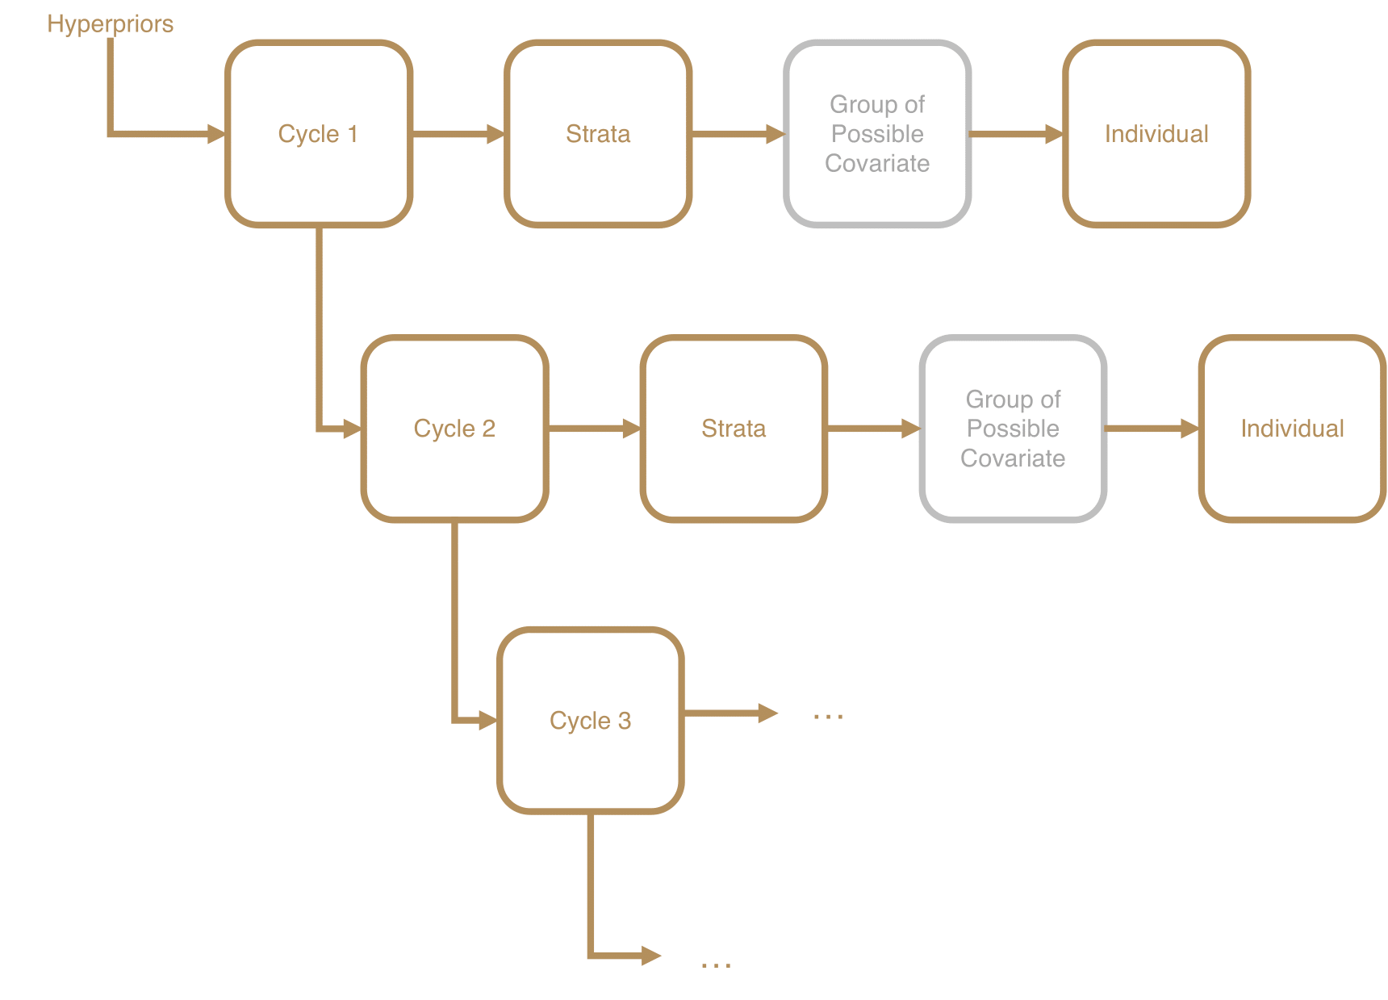

**Supplementary Figure 1:** *General Diagram for the hierarchical models. See appendix for a full specification of the models.*